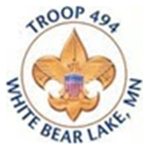
Shop for Holiday Wreaths & Popcorn online!
Sale ends October 29th Delivery on
-OR- after Nov. 18th

Pay with your credit card!

Please help support White Bear Lake Troop 494 Scouts by
purchasing holiday wreaths or popcorn.
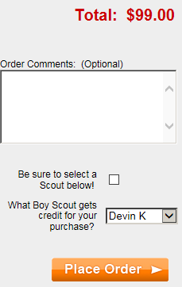
For Wreaths visit:
troop494store.org
At checkout make sure to note the name of the scout you are supporting.

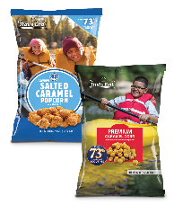
For Popcorn visit:
https://www.trails-end.com/sellers/support/code
Scout Name:
Popcorn Code:
Phone Number:

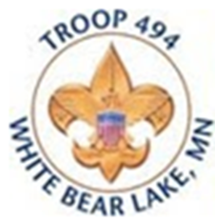
Shop for Holiday Wreaths & Popcorn online!
Sale ends October 29th Delivery on
-OR- after Nov. 18th

Pay with your credit card!

Please help support White Bear Lake Troop 494 Scouts by
purchasing holiday wreaths or popcorn.
For Wreaths visit:
troop494store.org
At checkout make sure to note the name of the scout you are supporting.

For Popcorn visit:
https://www.trails-end.com/sellers/support/code
Scout Name:
Popcorn Code:
Phone Number:

